Project Design Phase-II

Data Flow Diagram & User Stories

Date | 6 March 2026
Team ID | 699d5f8ac40b5ad0e9ee598f
Project Name | PlantCare AI - Plant Disease Detection System
Maximum Marks | 4 Marks

Data Flow Diagrams:

User Input: User selects and uploads a leaf image via the web browser.
Data Ingestion: Flask backend receives the POST request and saves the image to the local upload folder.
Transformation: Preprocessing script resizes the image to 224x224 and converts it to a normalized NumPy array.
Inference: The processed array is passed to the loaded MobileNetV2 model to generate class probabilities.
Output: The highest probability index is mapped to a disease name using class_names.json and rendered in the UI.

Entity / Process | Data Flow | Description
User (Farmer/Gardener) | Upload Image | The user selects a plant leaf image (PNG/JPG) from their device and submits it via the Web UI.
Process 1.0: Image Ingestion | Save to Storage | The Flask backend receives the file, validates the extension, and saves it to the local /static/images/uploads/ directory.
Process 2.0: Preprocessing | Normalized Array | The system retrieves the raw image and uses NumPy/Pillow to resize it to 224x224 pixels and normalize pixel values for the model.
Process 3.0: ML Inference | Class Probabilities | The preprocessed data is fed into the MobileNetV2 model, which outputs a vector of probabilities across 38 disease classes.
Process 4.0: Mapping & Results | Result Rendering | The system maps the highest probability index to a human-readable name using class_names.json and returns the prediction to the UI.
User (Farmer/Gardener) | View Diagnosis | The user receives the final plant name and disease identification on the results page.

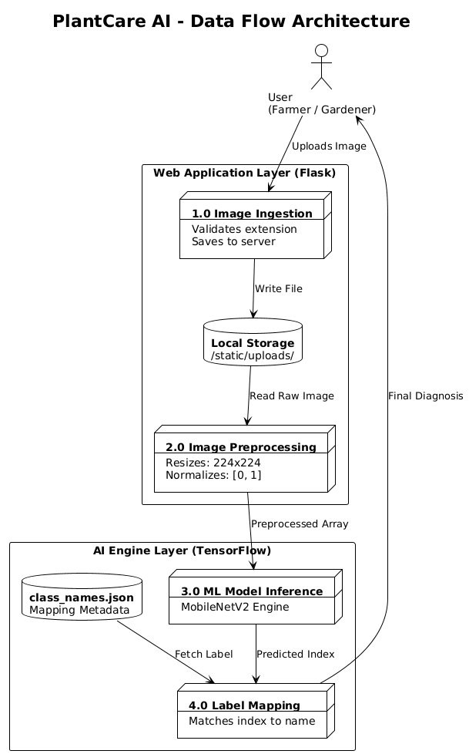

User Stories:

User Type | Functional Requirement (Epic) | User Story Number | User Story / Task | Acceptance Criteria | Priority | Release
Farmer | Disease Identification | US-1 | As a farmer, I can upload a leaf photo so I can identify the disease affecting my crop instantly. | System displays disease name (e.g., 'Wheat Yellow Rust') within 2 seconds. | High | Phase 1
Home Gardener | Plant Health | US-2 | As a gardener, I can use the web app on my phone to check for tomato blight. | UI is responsive on mobile browsers. | High | Phase 1
Agri-Tech Dev | API Integration | US-3 | As a developer, I can send images to the /predict endpoint to use the model in my own app. | Endpoint returns correct classification in response. | Medium | Phase 2
Student | Learning | US-4 | As a student, I can visit the 'About' page to learn how transfer learning works in this system. | About page loads with educational content. | Low | Phase 1

